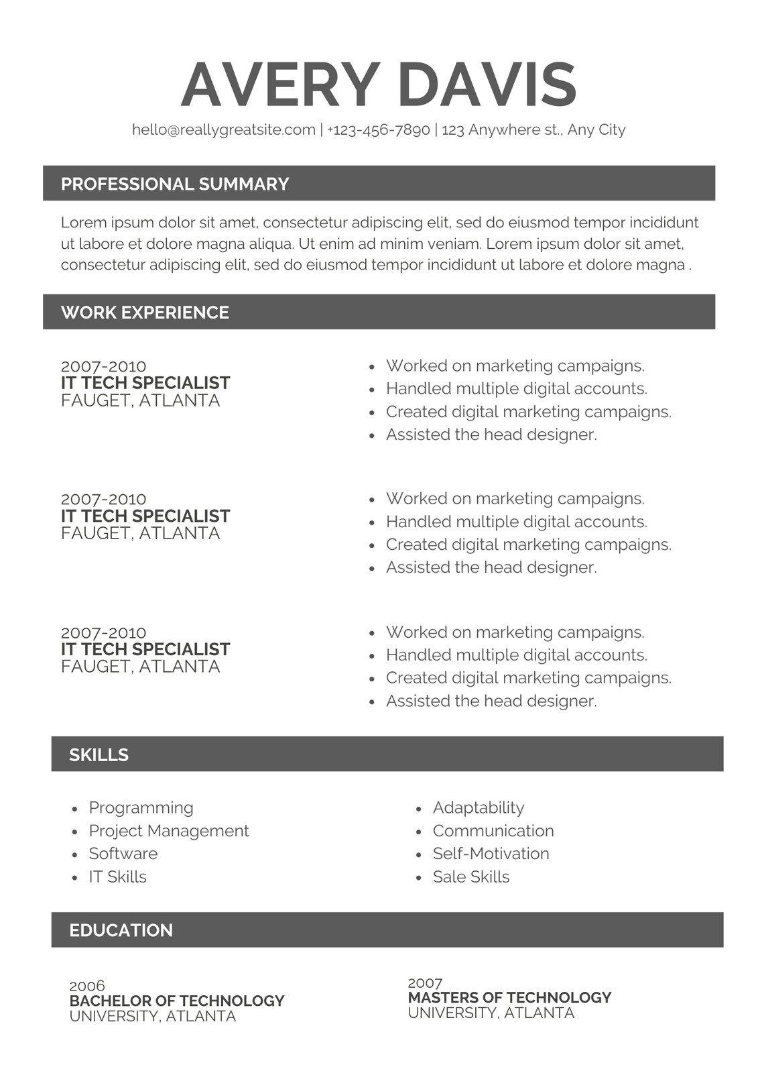
AVERY DAVIS
hello@reallygreatsite.com | +123-456-7890 | 123 Anywhere st., Any City
PROFESSIONAL SUMMARY
Lorem ipsum dolor sit amet, consectetur adipiscing elit, sed do eiusmod tempor incididunt ut labore et dolore magna aliqua. Ut enim ad minim veniam. Lorem ipsum dolor sit amet, consectetur adipiscing elit, sed do eiusmod tempor incididunt ut labore et dolore magna.
WORK EXPERIENCE
2007-2010
IT TECH SPECIALIST FAUGET, ATLANTA
2007-2010
IT TECH SPECIALIST FAUGET, ATLANTA
2007-2010
IT TECH SPECIALIST FAUGET, ATLANTA
• Worked on marketing campaigns.
•
Handled multiple digital accounts.
• Created digital marketing campaigns. • Assisted the head designer.
Worked on marketing campaigns. • Handled multiple digital accounts. Created digital marketing campaigns. Assisted the head designer.
• Worked on marketing campaigns. Handled multiple digital accounts. Created digital marketing campaigns. • Assisted the head designer.
@
SKILLS
•
•
Programming
Project Management
• Software
• IT Skills
EDUCATION
Adaptability Communication
• Self-Motivation
• Sale Skills
2006
BACHELOR OF TECHNOLOGY UNIVERSITY, ATLANTA
2007
MASTERS OF TECHNOLOGY UNIVERSITY, ATLANTA

